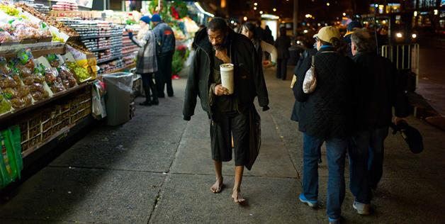

Barefoot homeless guy apparently has apartment, 30 pairs of shoes
1 hr ago
Jeffrey Hillman, better known as "the guy in that viral photo that a cop gave all those shoes and socks to," was recently profiled by the New York Post counting a stack of bills on the way back from "work" in Times Square. The Rev. John Graf, who says he pays Hillman's utility bills, admits that Hillman has 30 pairs of shoes in his Bronx apartment and has been "working the streets … for years," reportedly making up to $1,000 a day. NYPD Commissioner Ray Kelly offers the most levelheaded take on this news: "That's life in New York. ... But it was a generous act of kindness." He's right: Let's focus on the good in people, not the bad.

